- Created one ec2 instance for the project 2 as trend-server in AWS

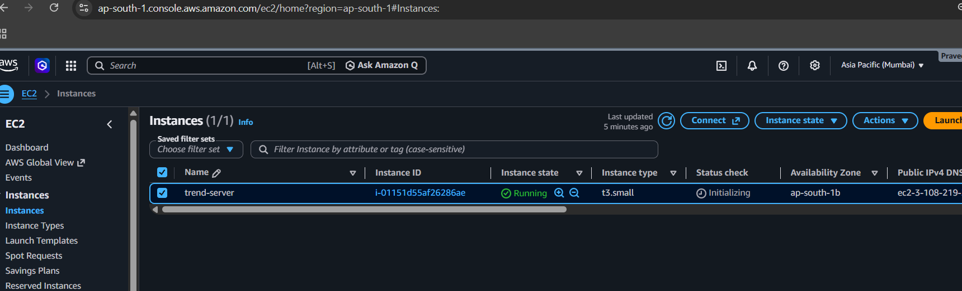

- Created the main trend-project directory on the EC2 instance, added the required subfolders, and documented the configuration details in the main.tf file.

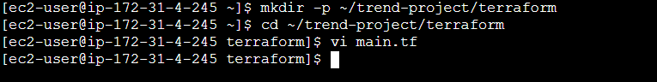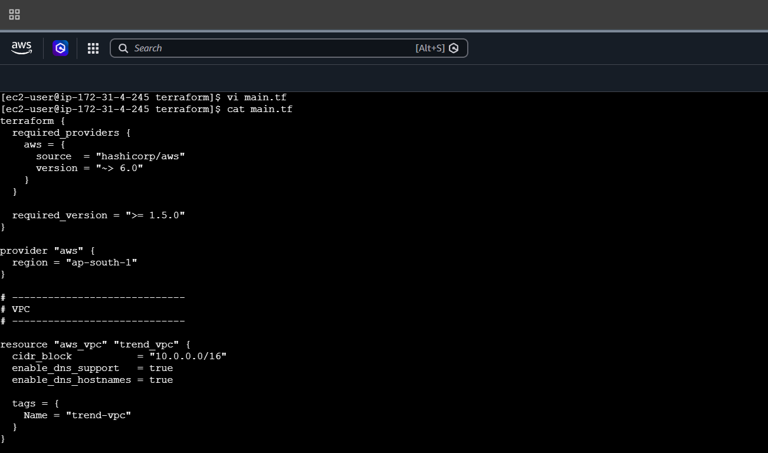

3.Initiated terraform and got the result as success.
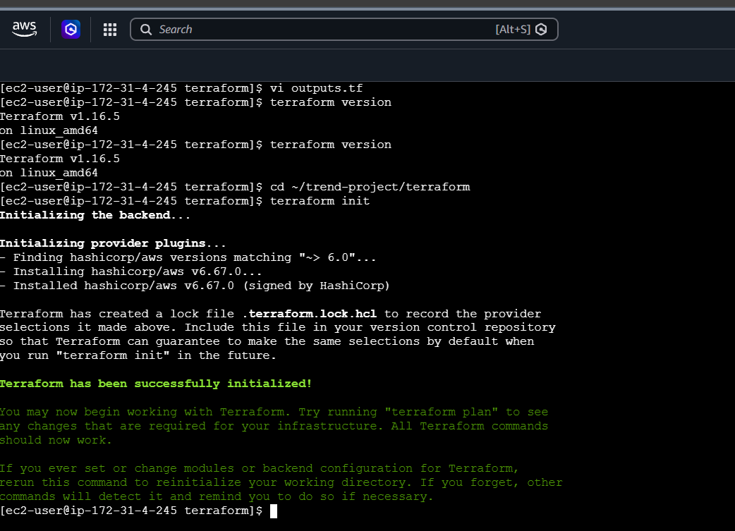

- Executed terraform validate, terraform plan, and terraform apply commands to validate the Terraform configuration, review the execution plan, and provision the required AWS resources.
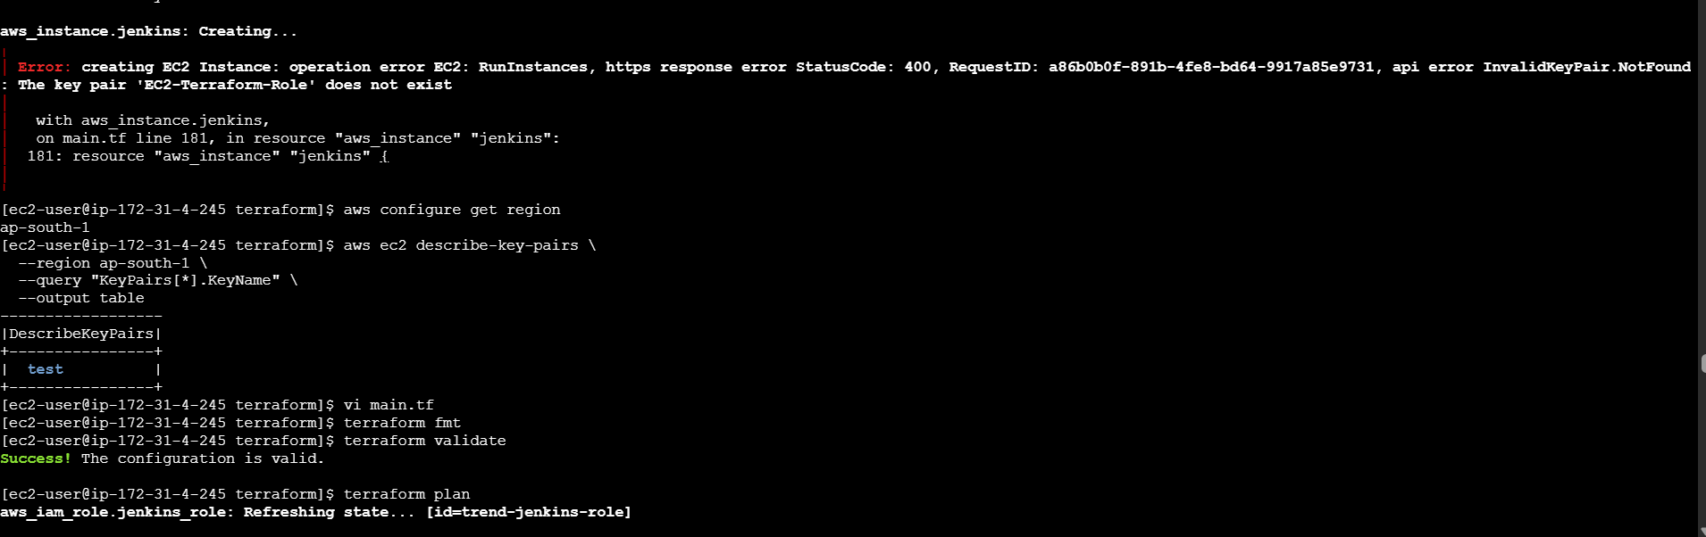

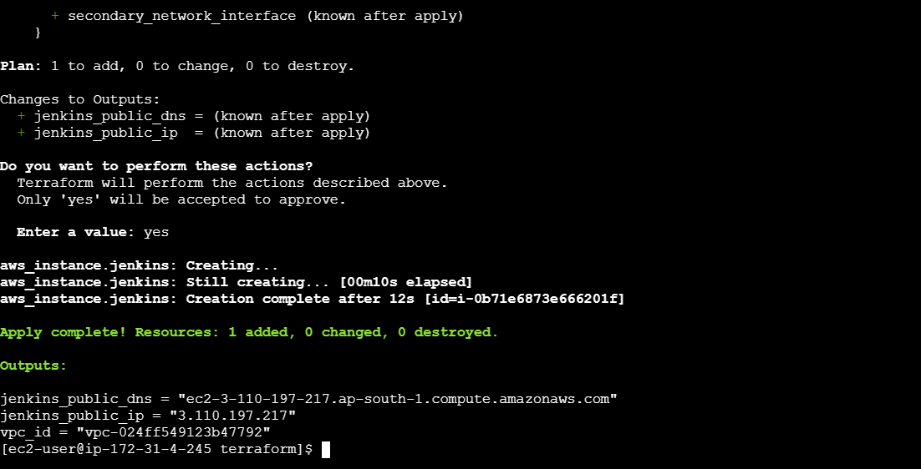

- Automatically created an EC2 instance named **trend-jenkins-server** based on the configuration and specified details provided in the `main.tf` file.

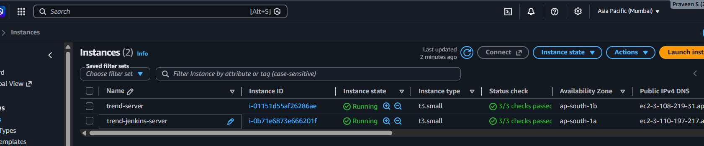

- Cloned the GitHub repository to the EC2 instance, created the Dockerfile, built and ran the Docker container, and verified the application in the browser using docker ps.
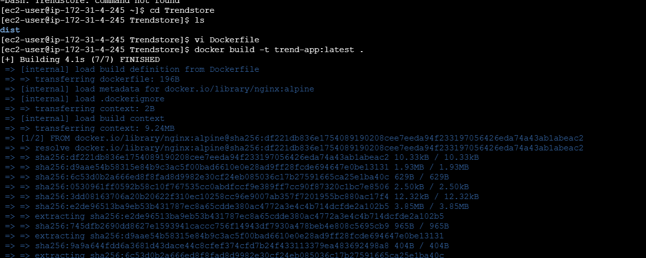


7. Created EKS cluster in EC2 and verified the status.
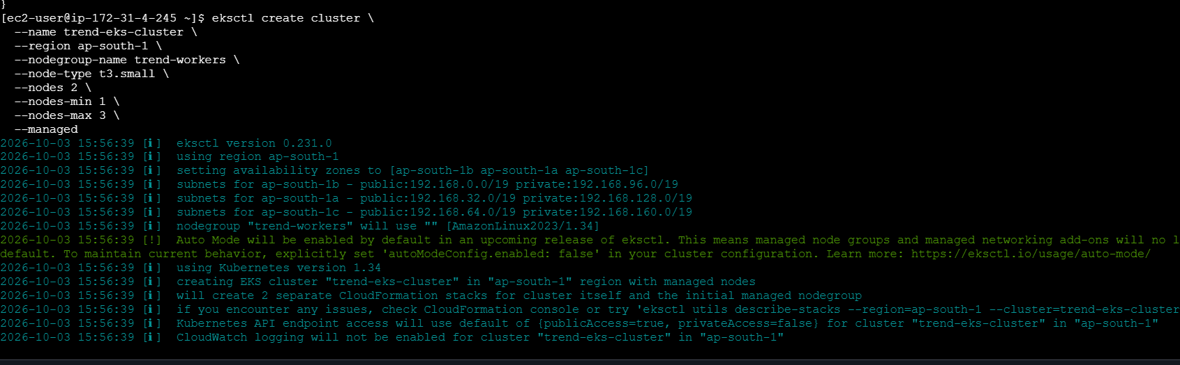
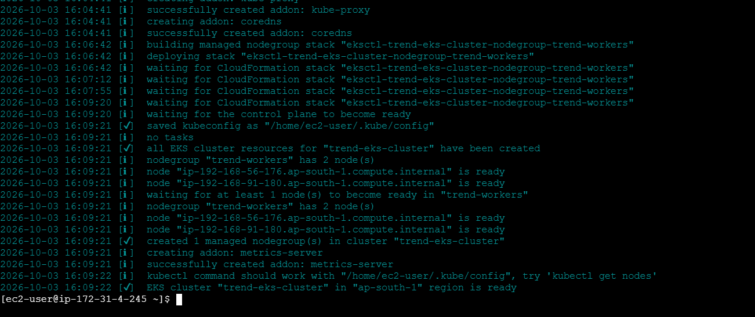
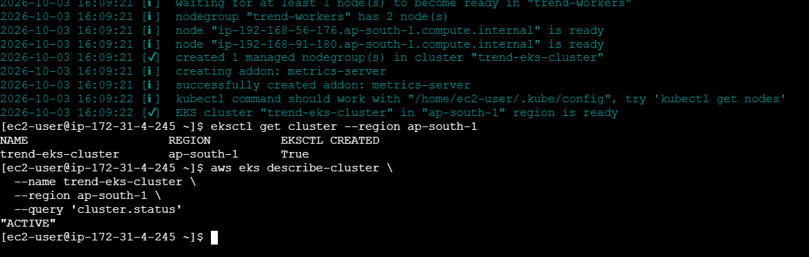
8. Connected kubectl to the EKS cluster and checked the pod status.
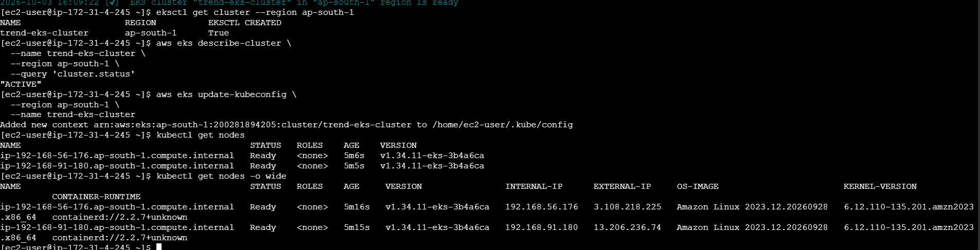

- Created Kubernetes Deployment and Service YAML files and verified the pod status.

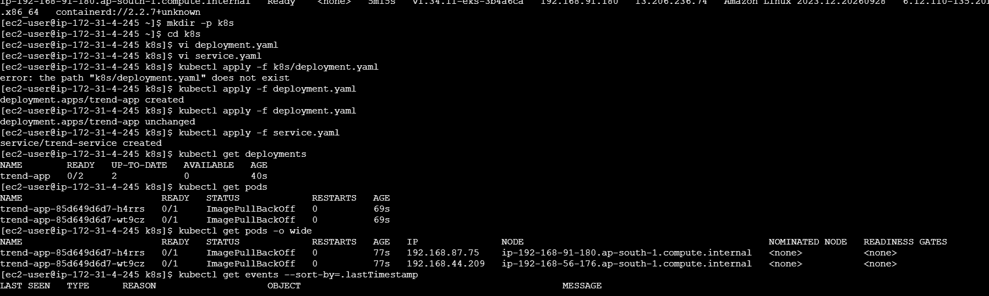
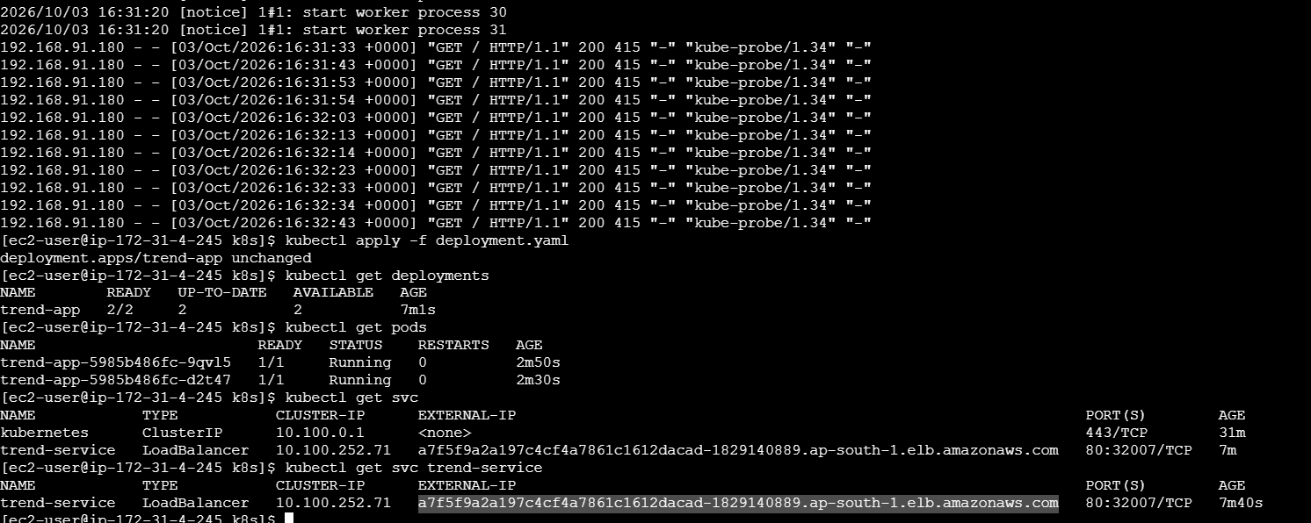

- Verified the application using the Load Balancer URL.


- Jenkins build completed successfully and the application was deployed successfully.

